|  |
| --- |
| LockedMe Project Submission  By  Rajat Jamkhandi |

**Date of Submission – 11-September-2022**

**Source Code Git Location:**

**https://github.com/Rajat266/Phase1-Project-LockedMe.git**

**[Kindly refer to the link for source code and project related files]**

|  |
| --- |
| **LockedMe Project Source Code** |
| **Source Code :-**  **package com.company.lockers;**  **import java.io.File;**  **import java.io.FileWriter;**  **import java.util.LinkedList;**  **import java.util.Scanner;**  **public class LockedMe**  **{**  **static final String projectPath="C:\\Users\\hp\\eclipse-workspace\\CompanyLockersProject\\LockedMeFiles";**  **public static void main(String[] args)**  **{**  **Scanner obj = new Scanner(System.in);**  **int ch;**    **do**  **{**    **displayMenu();**  **System.out.println("Enter your choice:");**  **ch=Integer.parseInt(obj.nextLine());**    **switch(ch)**  **{**  **case 1:getAllFiles();**  **break;**  **case 2:createFiles();**  **break;**  **case 3:deleteFiles();**  **break;**  **case 4:searchFiles();**  **break;**  **case 5:System.exit(0);**  **break;**  **default:System.out.println("Invalid Option");**  **break;**  **}**    **}**  **while(ch>0);**  **}**    **public static void displayMenu()**  **{**  **System.out.println("****************************************************");**  **System.out.println("\tWelcome to Company Lockers - LockedMe.com");**  **System.out.println("\tDeveloper Name : Rajat Jamkhandi");**  **System.out.println("****************************************************");**  **System.out.println("\t1. Display all the files");**  **System.out.println("\t2. Add files to existing directory");**  **System.out.println("\t3. Delete a file");**  **System.out.println("\t4. Search a file");**  **System.out.println("\t5. Exit");**  **System.out.println("****************************************************");**  **}**    **public static void getAllFiles()**  **{**  **File[] listofFiles = new File(projectPath).listFiles();**    **//if the folder is empty**  **if(listofFiles.length==0)**  **System.out.println("No files exist in the directory");**  **else**  **{**  **for(File l:listofFiles)**  **{**  **System.out.println(l.getName());**  **}**  **}**  **}**    **public static void createFiles()**  **{**  **try**  **{**  **Scanner obj = new Scanner(System.in);**  **String fileName;**  **int linesCount;**    **System.out.println("Enter file name:");**  **fileName=obj.nextLine();**    **System.out.println("Enter how many lines you want to add in file:");**  **linesCount=Integer.parseInt(obj.nextLine());**    **FileWriter fw = new FileWriter(projectPath+"\\"+fileName);**    **for(int i=1;i<=linesCount;i++)**  **{**  **System.out.println("Enter file content line:");**  **fw.write(obj.nextLine()+"\n");**  **}**    **System.out.println("File Created Successfully");**  **}**  **catch(Exception ex)**  **{**  **System.out.println("Some error occured.");**  **}**  **}**    **public static void deleteFiles()**  **{**  **Scanner obj = new Scanner(System.in);**  **try**  **{**  **String fileName;**  **System.out.println("Enter file name to be deleted:");**  **fileName=obj.nextLine();**    **File fl = new File(projectPath+"\\"+fileName);**    **if(fl.exists())**  **{**  **fl.delete();**  **System.out.println("File deleted successfully");**  **}**  **else**  **{**  **System.out.println("File do not exist");**  **}**  **}**  **catch(Exception Ex)**  **{**  **System.out.println("Some error occured");**  **}**  **}**    **public static void searchFiles()**  **{**  **Scanner obj = new Scanner(System.in);**  **try**  **{**  **String fileName;**  **System.out.println("Enter file name to be searched:");**  **fileName=obj.nextLine();**    **File fl = new File(projectPath+"\\"+fileName);**    **if(fl.exists())**  **{**  **System.out.println("File is available");**  **}**  **else**  **{**  **System.out.println("File is not available");**  **}**  **}**    **catch(Exception Ex)**  **{**    **}**  **}**  **}** |

**Screenshots of LockedMe Project –**

* **Welcome Screen**

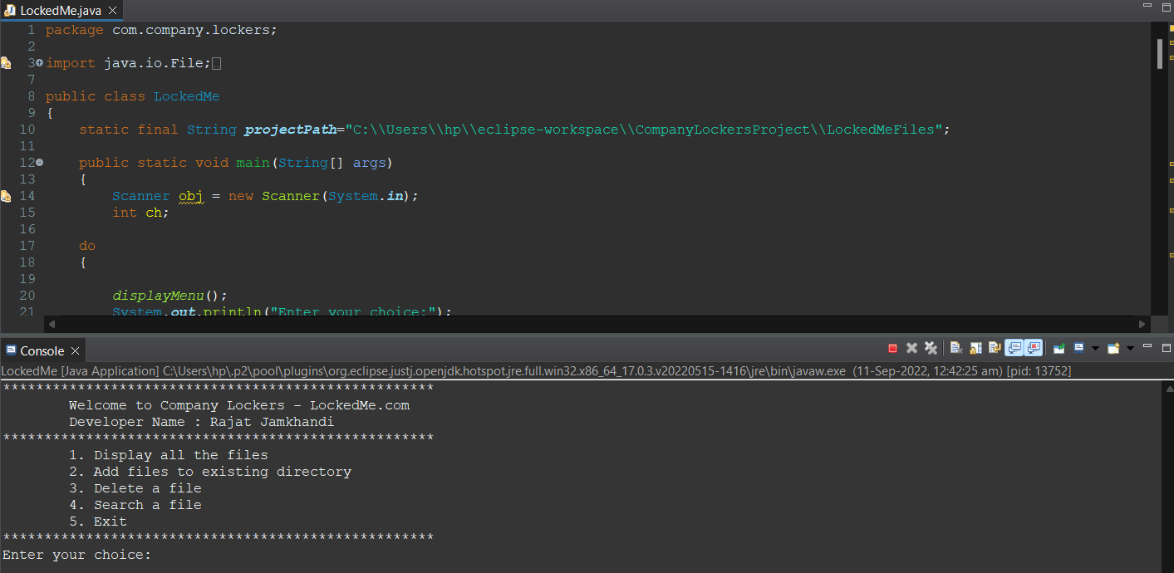

1. **Display all the files**

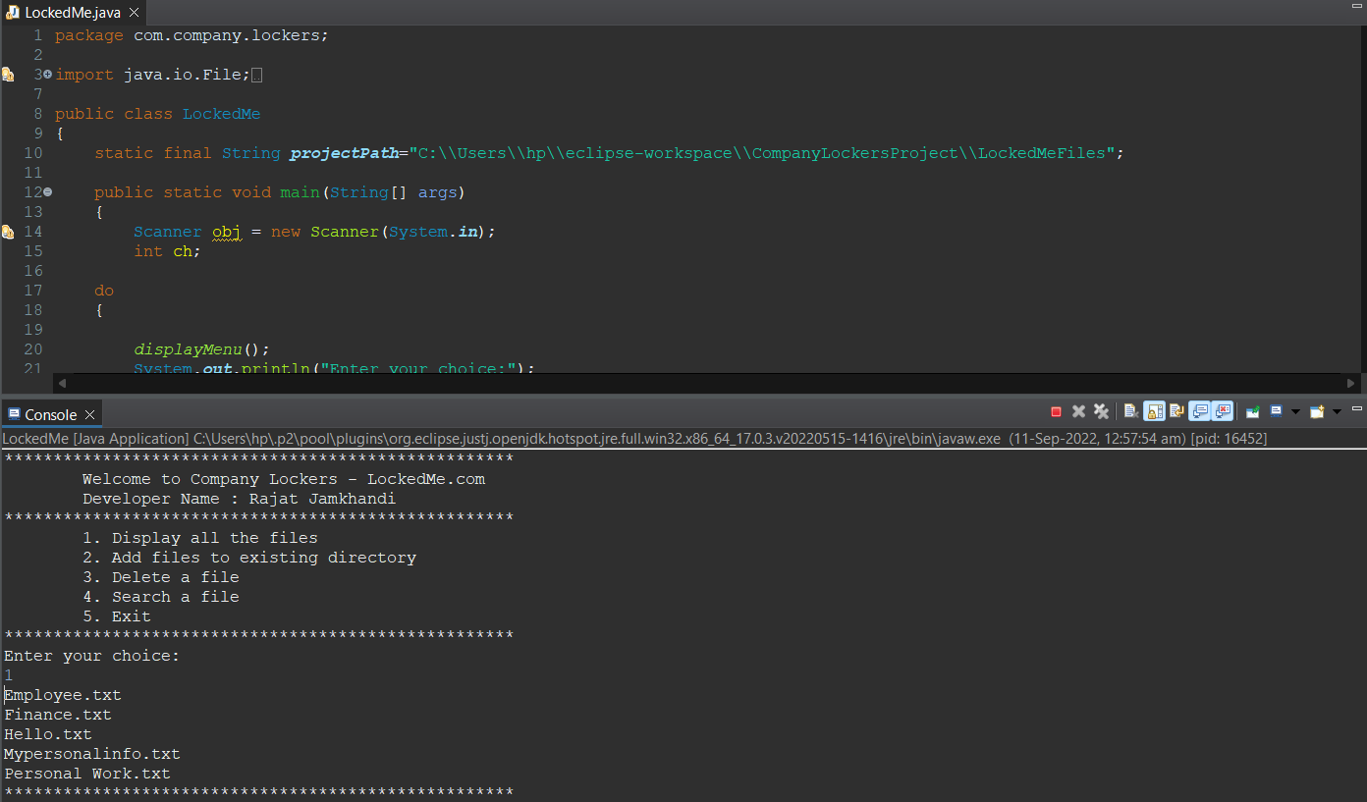

1. **Add files to existing directory**

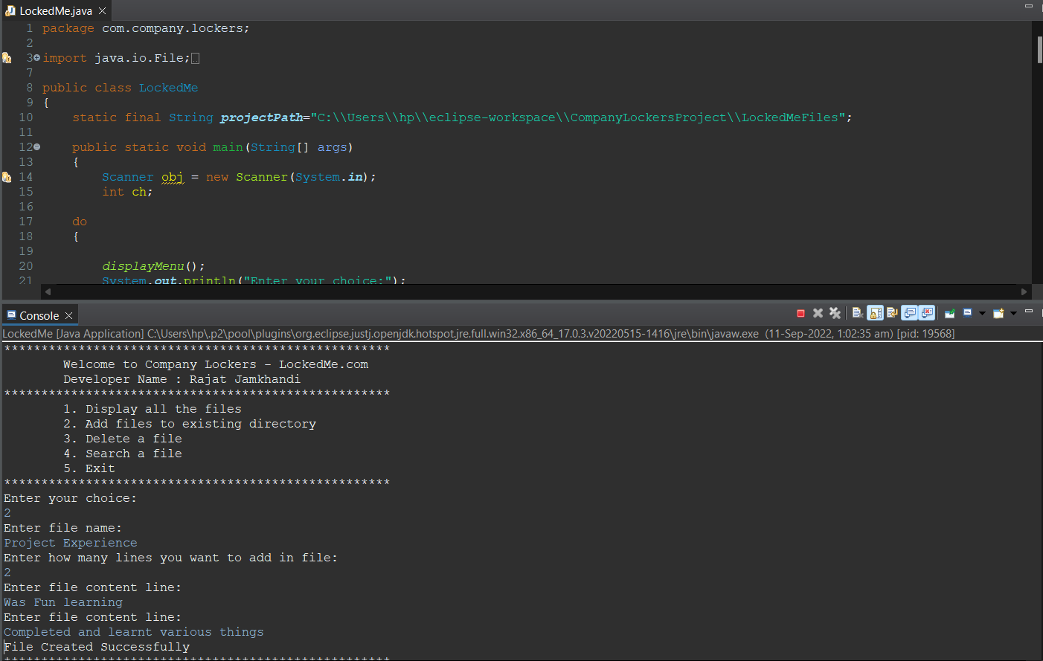

1. **Delete a file**

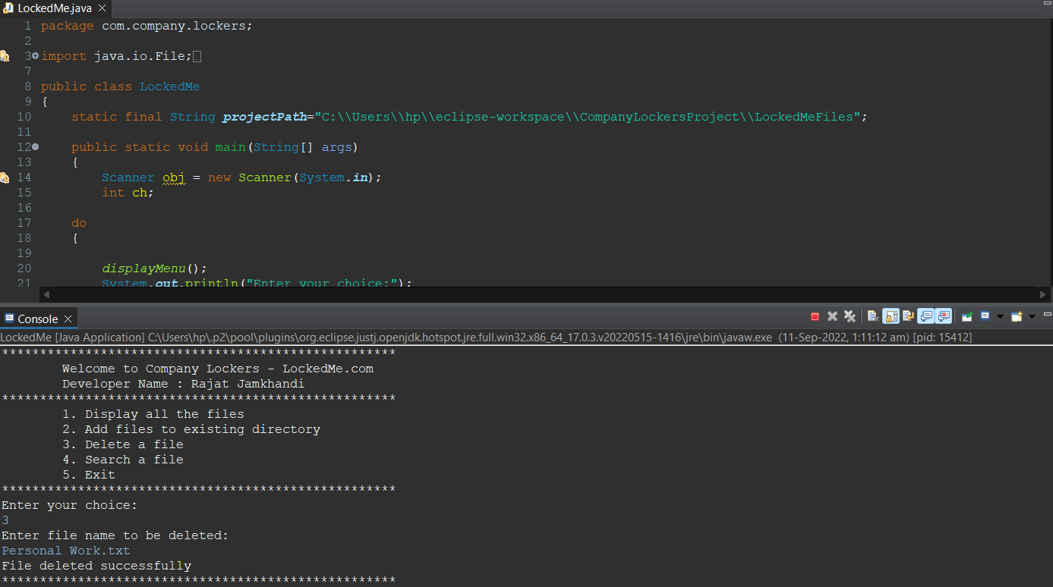

1. **Search a file**

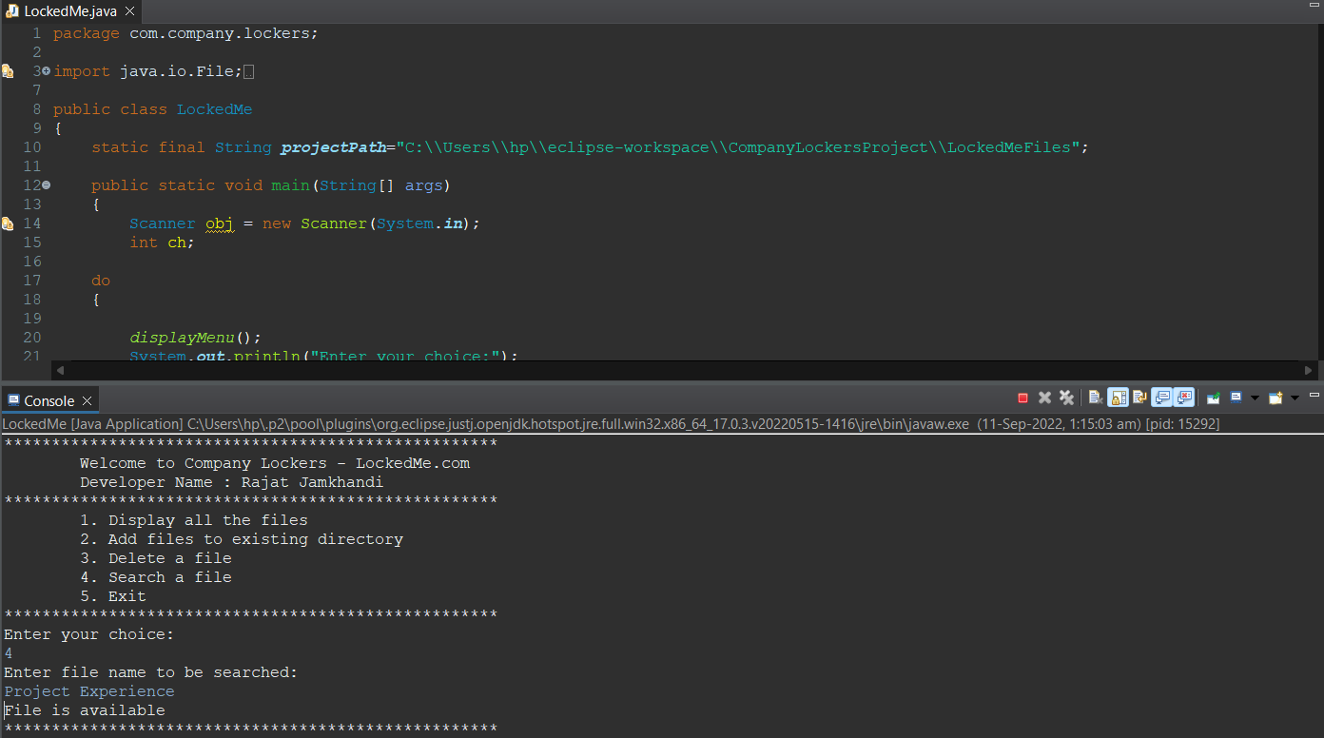

1. **Exit**

